**University of Petroleum and Energy Studies**

School of Computer Science

Department of Cybernetics



**GRAPHICS AND ANIMATION TOOLS LAB FILE**

*(Session: 2020-2021)*



Submitted To- Submitted By-

Dr. Durgansh Sharma Anshul Khattar

Assistant Professor Roll No. -13

Department of Cybernetics SAP ID -500063399

**Experiment 4:** Design your own animation using GIMP.

Step 1 : Open GIMP. Go to file->new. From the window that opens up select a template and set the required dimensions.

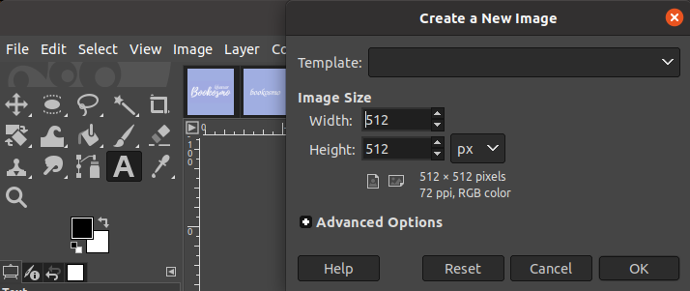

Step 2: Go to file->open as layers and select the image you want to insert and adjust the position of the image.

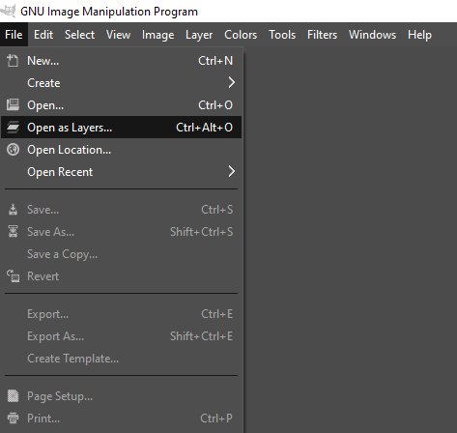

Step 3. Click on the text tool , create the area to write the required text. Choose text color and font style.

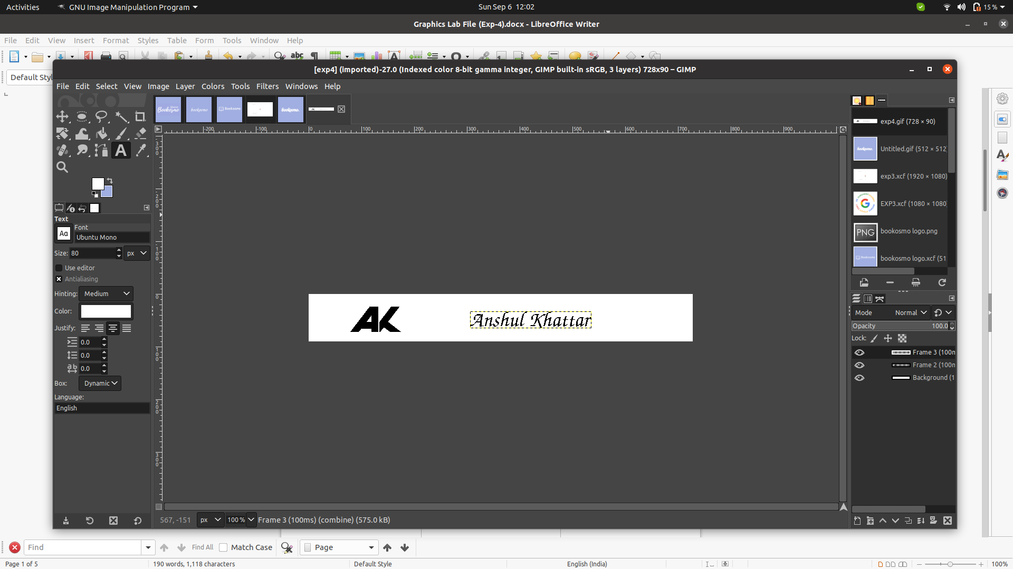

Step 4 : For the top 2 layers do the following:

1. Click on filters -> animations -> optimize(for gif)
2. Choose the animation to apply.

Output

